**Territory Optimization Report**

Zhaoying Meng

November 1, 2020

**Background**

Argentis is a growing financial services firm that specializes in providing investment services (annuities, managing stock portfolios, trust services) for higher net worth clients. Until recently, Argentis has only offered its services online. Plan its office locations in central Ohio and put together a plan that (1) places eight agent offices throughout central Ohio and (2) minimizes the amount of time Top 100 highest net worth clients in the area will have to travel to get to their local agent’s office. The dataset contains the latitude and longitude of these clients’ addresses.

**Initial Analysis**

I will use k-Means Clustering to identify the new agent’s locations. First of all, because we have determined to set up 8 agent offices in central Ohio, then k = 8. We randomly select 8 locations as offices (centroid), and then we assign each customer to the nearest Offices, forming 8 clusters. Then recalculate the centroid of each cluster until the cluster does not change. We have found the best locations for 8 offices. If the results obtained are unstable, for example, some offices allocate very few customers, and some offices allocate very many customers, then we will make adjustments. We can continue to try to change the value of k to get the most suitable office location.

**Results**

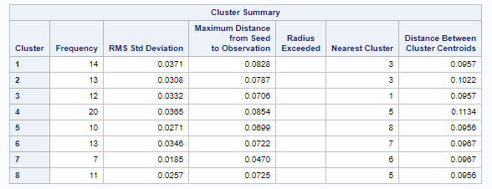

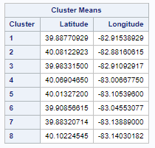 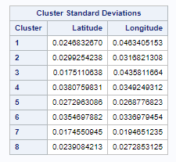

**Map**

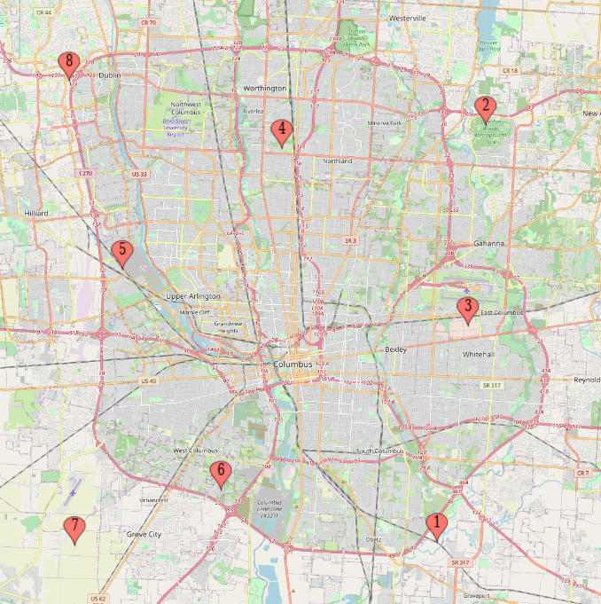

First of all, in the eight agent offices the smallest frequency in cluster 7 is 7 and the largest frequency in cluster 4 is 20. The others are concentrated in 10-14. The largest distance between two cluster centroids is 0.1134. The others are concentrated in 0.09. It shows that the number of customers served by these eight offices is relatively average, and the distance between them is also similar. From their distribution map, we can see that the eight locations are reasonably distributed in all directions in the south, east, north and west. I think this distribution is relatively reasonable, and it can averagely shorten the time spent by the top 100 clients with the highest net worth.

**Data visualizations**

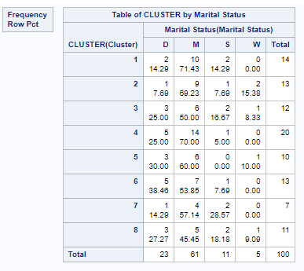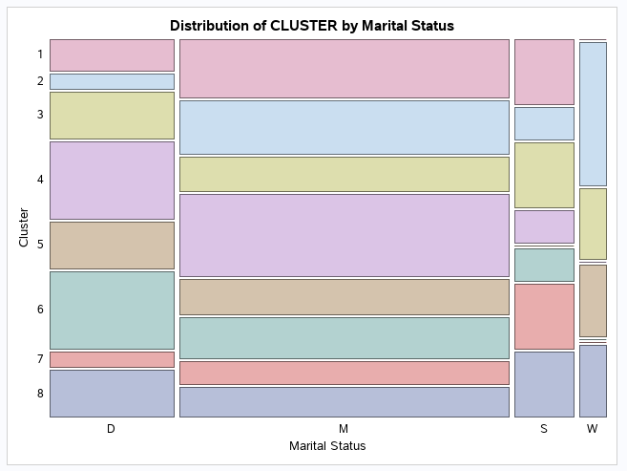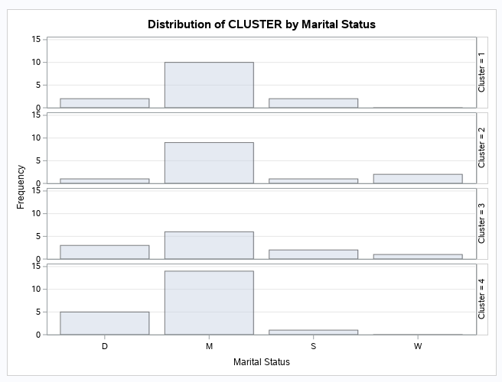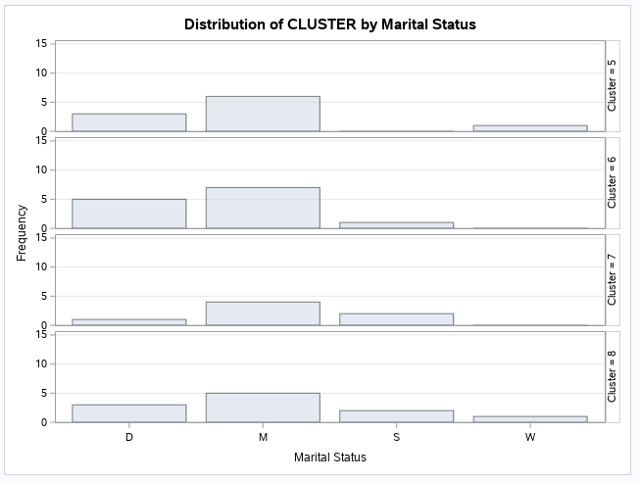

First of all, I think that married people have more investment potential than single, divorced and widowed people, because married families are two people earn money, pay relatively low taxes, and are more willing to spend money on investment. Therefore, I think the positions of agents 1, 2, and 4 are more advantageous because the proportion of married people in these three positions is higher. The percentage of married persons in other agents is around 50%, and there is no obvious disadvantage.

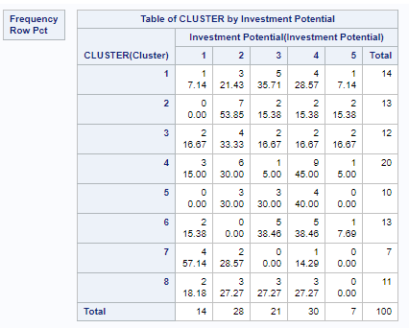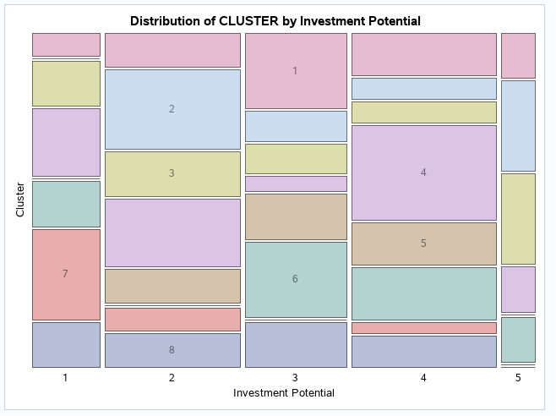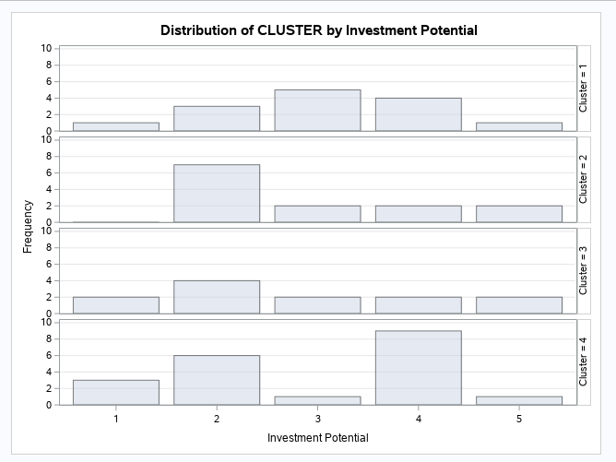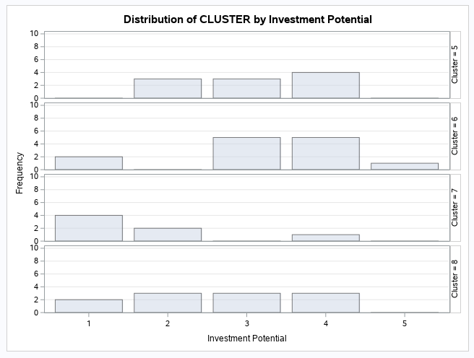

First of all, I think people with investment potential scores of 3, 4, and 5 have more potential. So I calculated the ratio of the sum of 3, 4, and 5 for each agent. The results are shown in the table below. Therefore, I think agent positions 1, 5, and 6 are more advantageous because the investment potential of 3, 4, and 5 are all above 70%. However, agent 7 is only 14.29%. I think agent 7 has a significant disadvantage compared to other agent positions.

|  |  |  |
| --- | --- | --- |
| Cluster | Frequency Investment Potential 3, 4 ,5 | Percent Investment Potential 3, 4 ,5 (%) |
| 1 | 10 | 71.42 |
| 2 | 6 | 46.14 |
| 3 | 6 | 50.01 |
| 4 | 11 | 55.00 |
| 5 | 7 | 70.00 |
| 6 | 11 | 84.61 |
| 7 | 1 | 14.29 |
| 8 | 6 | 54.54 |
|  |  |  |

**New Plan**

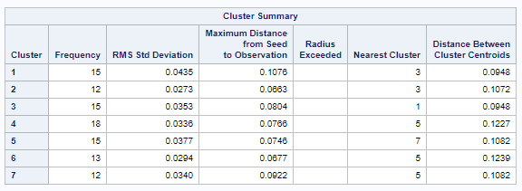 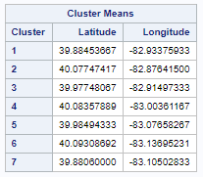 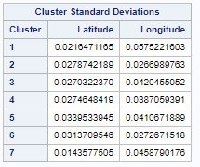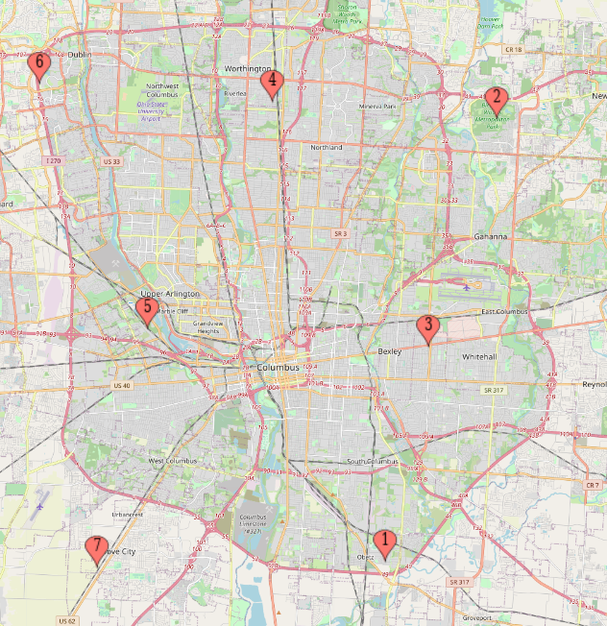 

First, reducing the eight agent offices to seven makes the number of customers served by each agent more even. For example, the range of the number of customers has changed from 7 - 20 to 12 - 18. The maximum distance between the centroids of two clusters has changed from 0.1134 to 0.1239. Observed from the map, the location of each agent has not changed much, except that the original location of agent 6 has been cancelled, and the locations of agent 5 and agent 7 have some changes. The changes are shown in the table below. The average distance between customers and agents has increased from 0.0724 to 0.0808, an increase of 0.0084.

|  |  |  |
| --- | --- | --- |
| Cluster | Latitude | Longitude |
| Original 5 | 40.01327200 | -83..10539600 |
| New 5 | 39.98494333 | -83.07658267 |
| Original 7 | 39.88320714 | -83.13889000 |
| New 7 | 39.88060000 | -83.10502833 |